# FINAL REPORT ON

**STUDENT STUDY PORTAL**



# Submitted for the partial fulfillment for the award of the degree of the

## Bachelor of Technology IN

**(Computer Science & Engineering)**

## SUBMITTED BY:

**Sahil: 1809424**

## Nikhil Dhiman: 1908578

**SUBMITTED TO:**

## Dr. Dinesh Garg

**DEPARTMENT OF COMPUTER SCIENCE & ENGINEERING SRI SAI COLLEGE OF ENGINEERING AND TECHNOLOGY**

# FINAL REPORT ON

**STUDENT STUDY PORTAL**

# Submitted for the partial fulfillment for the award of the degree of the

## Bachelor of Technology IN

**(Computer Science & Engineering)**



## SUBMITTED BY:

**Sahil: 1809424**

## Nikhil Dhiman: 1908578

**SUBMITTED TO:**

## Dr.Dinesh Garg

**DEPARTMENT OF COMPUTER SCIENCE & ENGINEERING SRI SAI COLLEGE OF ENGINEERING AND TECHNOLOGY BUNGAL, PATHANKOT**

# TABLE OF CONTENTS

## Topic Page No.

Declaration 4

|  |  |
| --- | --- |
| Abstract | 5 |
| Acknowledgement | 6 |
| Introduction to the organization | 7 |
| **Chapter 1:**  Introduction of the project | 8-10 |
| **Chapter 2:**  Technology Used | 11-15 |
| .Imported Libraries and Components | 16 |
| **Chapter 3:**  Feasibility Study | 17-18 |
| **Chapter 4:**  Methodology | 19 |
| code and explanation | 20-22 |
| **Chapter 5:**  Results and Discussions | 23-24 |
| **Chapter 6:**  Conclusion and future scope | 25 |
| **Bibliography**  Website referred | 26 |
| Reference Books | 26 |

**DECLARATION**

We, hereby declares that we have undertaken 6 months Software Training at excellence technology during a period from January 2021 to June 2022 in partial fulfillment of requirements for the award of degree of B.Tech. (Computer Science & Engineering) at SRI SAI COLLEGE OF ENGINEERING AND TECHNOLOGY, BUNGAL (PATHANKOT).

The work which is being presented in the training report submitted to Department of Computer Science & Engineering at SRI SAI COLLEGE OF ENGINEERING AND TECHNOLOGY, BUNGAL(PATHANKOT) is an authentic record of training work.

Dated: 16 -JUNE-2022

SAHIL:1809424 NIKHIL DHIMAN: 1908578 B.TECH 8TH Sem

# ABSTRACT

We have done my six months industrial training at excellence technology . to improve our technical abilities in computer science.

Our topic for this training was to learn the concepts of website development and how to create an website. The design of such an application uses django and flask and the coding language used is python. We have used to learn website development and to create my project. The purpose of the final application is to help kids to develop important skills needed in school and promote bonding between parents and kids.

This training allowed me to increase my knowledge and skills in programming and developing application for website platform.

# ACKNOWLEDGEMENT

The successful completion of this training marks the beginning of an ever-going learning experience of converting ideas and concepts into real life and practical system. This training is a quite learning experience for me at each and every step. At the same time, it has given me the confidence to work in professional setup as website Development is very booming technology nowadays. We feel the experience gained during this training will lead me to gain bright prospect in the future. we would like to thank Miss. Anjali CEO, Excellence Technology for giving me the opportunity to do my training within the organization.

We also would like to thank all the people that worked along with me at excellence technology With their patience and openness, they created an enjoyable working environment.

It is indeed with a great sense of pleasure and immense sense of gratitude that we acknowledge the help of these individuals.

We are highly indebted to SRI SAI COLLEGE OF ENGINEERING AND TECHNOLOGY for the facilities provided to accomplish this training.

We would like to thank our teacher Mr. Sourav Yadav for his constructive criticism throughout my training. His guidance, support and motivation enabled me to achieve the goals of the training.

Sahil (1809424)

Nikhil Dhiman (1908578) B.TECH CSE 8th sem

## Introduction to the Organization

Excellence Technology is one of the top reputed ISO 9001:2015 Certified Software Development Company in Chandigarh, Mohali and Panchkula We develop a mobile application, Games, antivirus and websites.We provide Best Php, Java, Web Designing and Android training on live projects of our off shore clients. We provide affordable deals in Website Designing and Development with a wide spectrum of courses in software, networking, automation, digital marketing, MBA and many more with a state-of-the-art infrastructure and spacious classrooms at Excellence Technology.

We provide the best learning environment for our students where they can develop their skills. Best Digital Marketing training in Chandigarh, Mohali and Panchkula, SEO/SMO, ORM (Online Reputation Management), Apart from that we also provide Best job oriented courses in Chandigarh.100% Practical training on real-time projects with a stipend.Students who are capable can get a stipend based internship or training in Chandigarh on PHP, web designing, android and digital marketing.

Excellence Technology is one of the top reputed ISO 9001:2015 Certified Software Development Company in Chandigarh, Mohali and Panchkula We develop a mobile application, Games, antivirus and websites.We provide Best Php, Java, Web Designing and Android training on live projects of our off shore clients. We provide affordable deals in Website Designing and Development with a wide spectrum of courses in software, networking, automation, digital market



# CHAPTER - 1

**1. INTRODUCTION OF PROJECT**

Student study portal is a portal with following features in its dashboard to make students life easy and more manageable.

1. In this project users can create text notes and refer them later, they are store permanently until deleted.

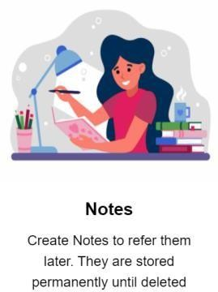

1. Users can add homework and assign them deadlines, they will be displayed prioritized by deadlines

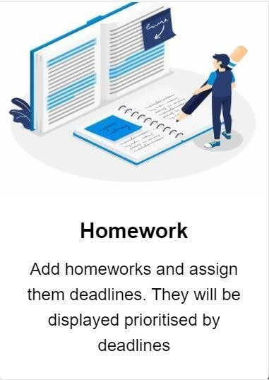

1. Users can add to do list for their day and remove them as the work is finished.
2. Users can browse books from a list of neatly organized book menu.

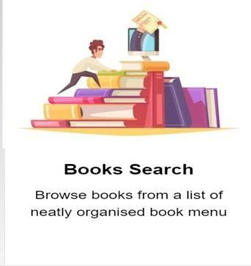

1. Users can enter a word and the meaning will be displayed along with its phonetic description incautiously.

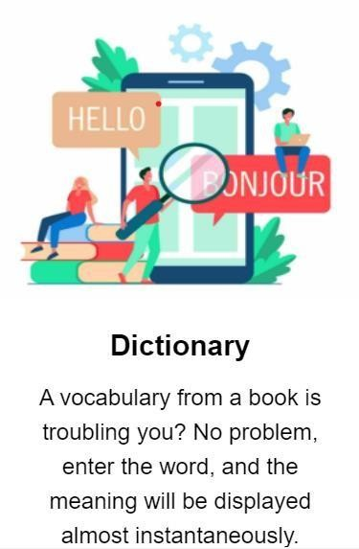

1. Users can search Wikipedia to get fast results.

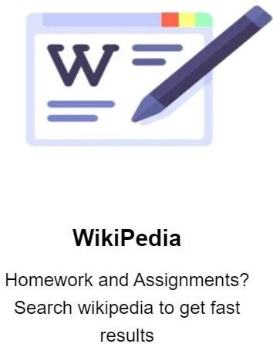

1. A virtual wallet is implemented to help the users to manage their expenses and keep track of it

.

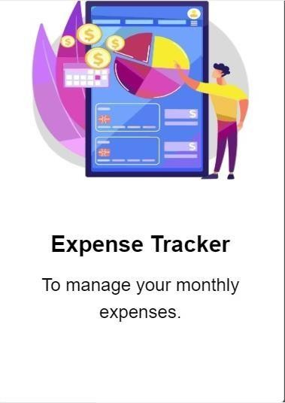

# CHAPTER -2

**2.1 TECHNOLOGY USED:**

**Python -** Python is a popular programming language. It was created by Guido van Rossum, and released in 1991.

It is used for:

* web development (server-side),
* software development,
* mathematics,
* system scripting
* Python can be used on a server to create web applications.
* Python can be used alongside software to create workflows.
* Python can connect to database systems. It can also read and modify files.
* Python can be used to handle big data and perform complex mathematics.
* Python can be used for rapid prototyping, or for production-ready software development.



**Django -** Django is an advanced Web framework written in Python that makes use of the model view controller (MVC) architectural pattern. Django was created in a fast-moving newsroom environment, and its key objective is to ease the development of complicated, database-driven websites. This Web framework was initially developed for The World Company for managing some of their news-oriented sites. In July 2005, it was publicly released under a BSD license

Django is available as an open-source Web framework, and it uses Python extensively to create files, settings and data models. It is designed to address two main challenges: the rigorous requirements of highly experienced Web developers and the intense deadlines of a newsroom. Django concentrates more on automating wherever possible and sticking to the "don't repeat yourself" principle.

Django emphasizes the following:

* Pluggability and reusability of components
* Quick development
* The principle of non-repetition

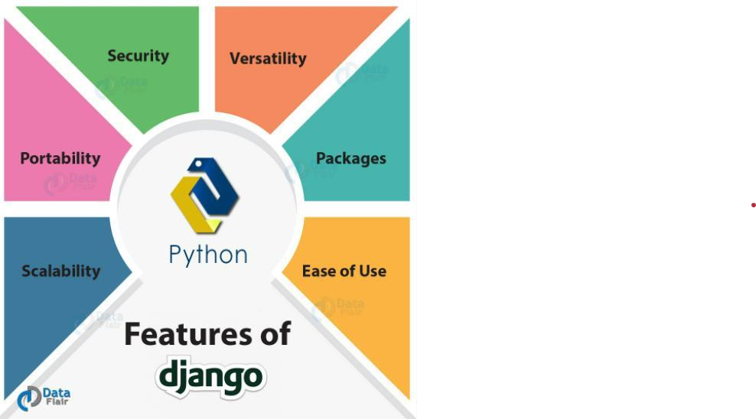

**Flask -** A web framework is a software architecture that contains tools and libraries used to develop a web application in a fast and efficient way. Flask is a microframework written in Python. It was developed by Armin Ronacher and has a BSD license. It is based on the Werkzeug toolkit and Jinja2 template. Here,

1. **WSGI (Web Server Gateway Interface):** It is used as a universal interface between the web server and the web application
2. **Werkzeug**: It is a WSGI toolkit and is used for implementing requests, response objects, and other utilities. It is used to build a web framework on top of it.
3. **Jinja2**: It is a templating engine that combines a template and a data source to develop a dynamic website.

It provides only core functionalities including form validation, upload handling, object-relational mappers, open authentication, etc. Using these, one can build both small and large scale websites. It does not have a database abstraction layer, form validation, and additional functionalities but it provides extensions to implement these

